SRI CHANDRASEKHARENDRA SARASWATHI VISWA MAHAVIDYALAYA
(UNIVERSITY ESTABLISHED UNDER SECTION 3 OF UGC ACT 1956)
ENATHUR, KANCHIPURAM – 631 561

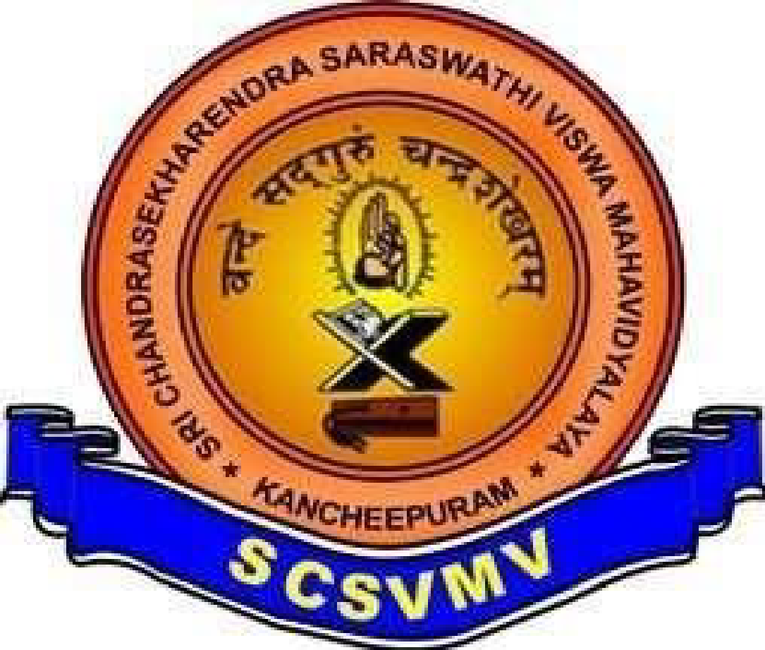
DEPARTMENT OF COMPUTER SCIENCE & ENGINEERING

Name: Dhurjati V B K Sai Sushanth
Reg. No: 11249A426
Class: S7 II B.E.(CSE)
Course Name: OOPS LEETCODE PROBLEMS

